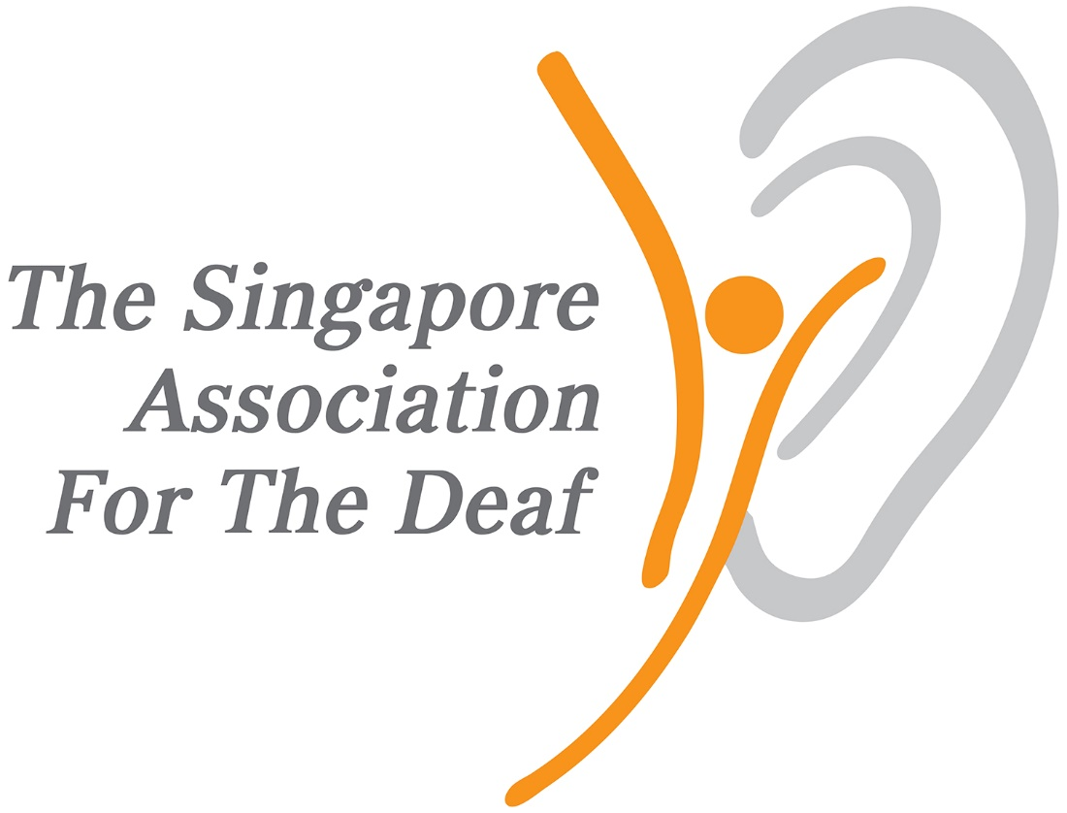
 | Referral form for Itinerant Support Service (ISS)
 | Scan and email this form together with the supporting documents to iss_enquiry@sadeaf.org.sg
- Child's Personal Details
Name (as per BC/NRIC) :
Gender : * M / F |  | BC / NRIC :  Date of Birth : |  |  |  | Citizenship :  * SG Citizen / **PR |  |  |  | For PR, indicate the number of immediate family members who are SG Citizen ( )
Address :
Postal code : ( )
- Education Information
Name of school : |  |  |  |  |  | Level : * N1 /N2 / K1 /K2 |  |  |  |  | Others:
- Primary Diagnosis & Assistive Devices
Level of Hearing Loss : |  |  |  |  |  |  |  | Aided | Unaided  (please tick accordingly)
Type of Aids : Hearing Aids Cochlear Implants BAHA FM / Roger System

Others: _______________________
(please tick accordingly)
Other Medical Condition (if any) :
- Referrer's Details
*(Mr/Mrs/Miss/Mdm/Dr) Full Name :
Name of Organisation :
Department :
Designation :
Direct Contact No :
Email :
- Parent/Caregiver Information
* (Mr/Mrs/Miss/Mdm/Dr) Full Name :
Address (if different as above) : Postal code : ( )
Relationship to Child :
Home phone : |  |  |  |  | HP: |  |  |  | Email :
- Consent by Parent/Caregiver
I, ____________________________ (Name of Parent/Guardian), understand that my child ______________________________ (Name of Child) has special educational needs and has been recommended to enrol into the ISS programme.
I declare that the information that I have given in this form is true and complete and that I have not withheld any relevant information. I hereby also give consent for the release of this information to relevant professionals and/or agencies, and for SADeaf to contact me, in order to facilitate the application.
_____________________________
Parent / Caregiver Signature & date
Note: Please allow us 3 working days to acknowledge receipt of this referral.
* Please circle appropriately
**PRs without one immediate family member (IFM) who is a Singapore Citizen will be considered on a case-by-case basis.
 | Supporting Documents required tick accordingly (√ ):
 | Audiogram validated for 1 year
 | Doctor's memo on hearing loss
 | Other medical documents (if any)

